**Prepare Your Device for Creating LWC Projects:**

1. Open Terminal in your Mac Book by writing Terminal in serach:

1. A screenshot of a computer

   Description automatically generated with low confidenceType cmd in search. Run command prompt. Check if java is installed by typing ( java –version )

After you write java –version (green part) and click enter if you do not see red part that is mean you do not have Java installed so ccontinue with step 3.

1. A screenshot of a computer

   Description automatically generated with medium confidenceInstall java if not installed. Install Java Development Kit (JDK) we recomend version 17.0.7. You can reach that version from following link:

https://www.oracle.com/java/technologies/downloads/#jdk17-mac

Select JDK 17 and you computer system (Mac) then downlaod and install as other regular program.

1. Now, go back to terminal and check if Java installed to your computer or not. Write (Java –version) and click enter.

As you can see I have Java 17.0.7 installed in my device.

1. Set the JAVA_HOME environment variable to point to your JDK installation. Open a terminal and enter the following command:

**export JAVA_HOME=/Library/Java/JavaVirtualMachines/<jdk_version>/Contents/Home**

Note: Change ‘<jdk_version>’ to the version you got as an result of the previous step.

For Example: The above command will updated as follow for me:

**export JAVA_HOME=/Library/Java/JavaVirtualMachines/jdk-17.0.7.jdk/Contents/Home**

1. Verify that JAVA_HOME is set correctly by running the following command:

🡺 echo $JAVA_HOME

1. Install VSCode (<https://code.visualstudio.com/download> )
2. İnstall SFDX CLI ( <https://developer.salesforce.com/tools/sfdxcli> )
3. Open command promt and write ‘sfdx update’ click enter and wait .

1. After finishing the installation , to check if everything is done, write ‘’sfdx –version’’ clinc enter and see the version of SFDX .
2. Open VSCODE
3. Install extension Salesforce Extension pack (9)
4. İnstall Prettier code formatter
5. After installing everything
6. ‘’ View’’ 🡪 ‘’command palette…’’ 🡪 ‘’SFDX: Create Project with manifest’’ 🡪Select Standard 🡪 give a name for ythe project and save the project on your computer
7. ‘’View’’ 🡪‘’SFDX: Authorize an org’’ 🡪 ‘’Project Default’’ 🡪 give an allias to your org which you v=want to connect with newly created project
8. Choose the org which you want to sync with your project

You are ready to go further

**VScode**

**Creating Project:**

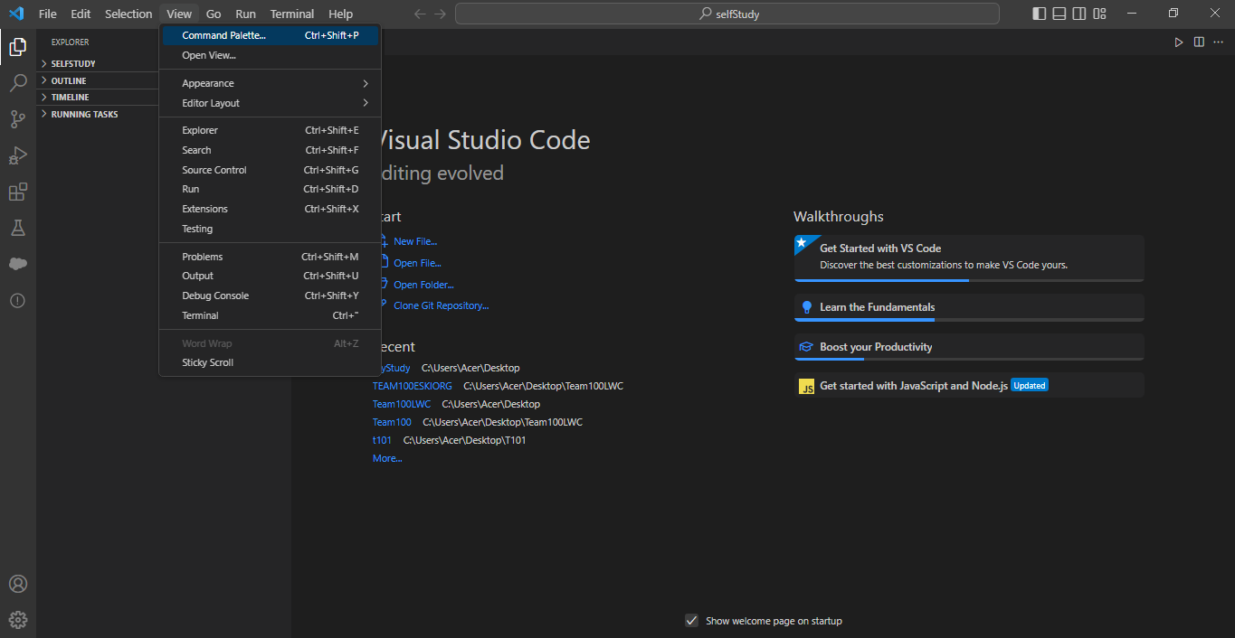

1

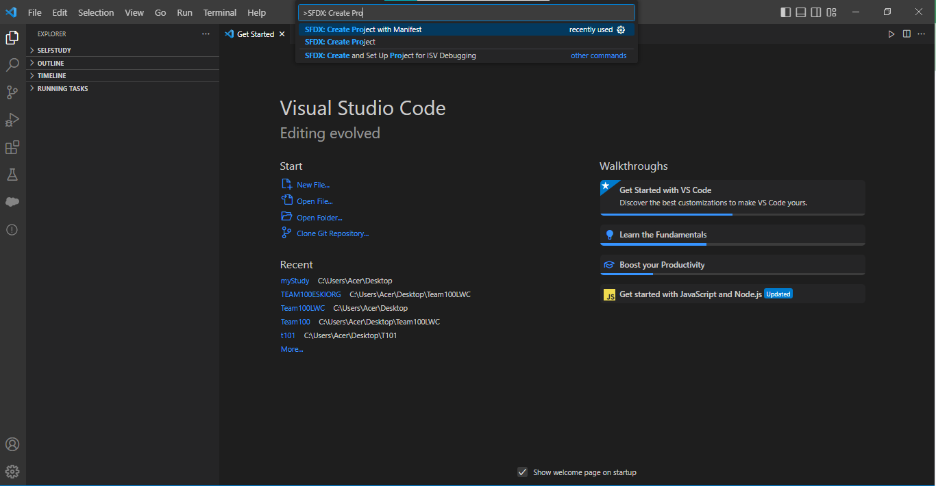

2

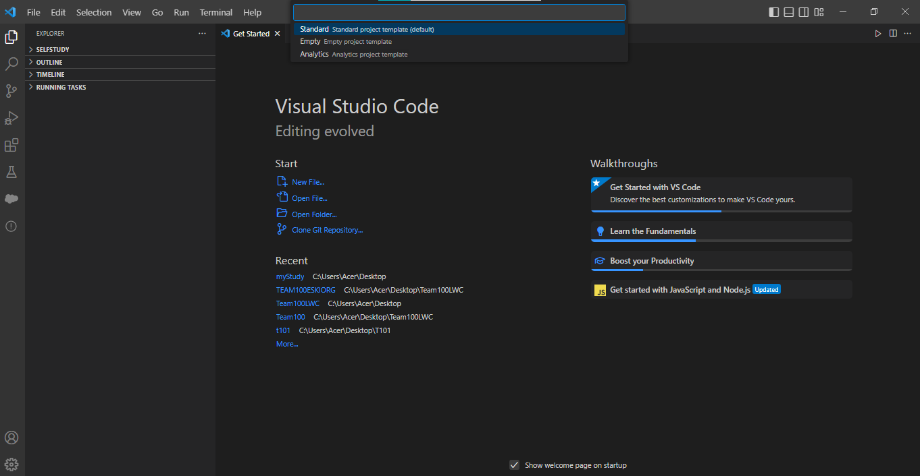

3

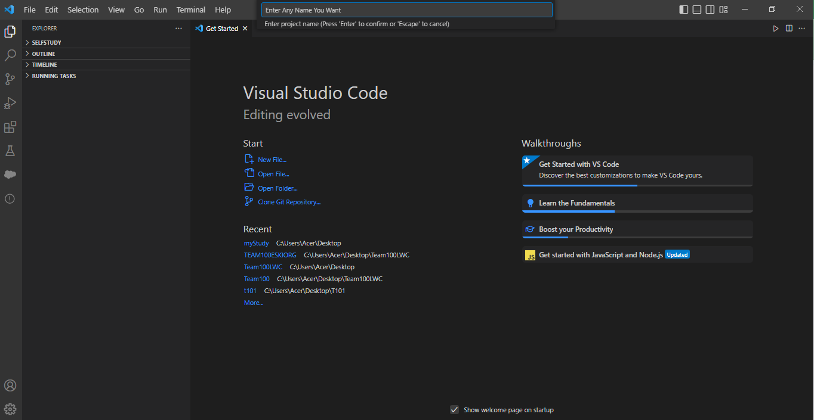

4

**After Writing The name of Project, click ENTER and choose your previously created folder. Then click ‘Create Project’ button.**

**Connecting VScode to Org:**

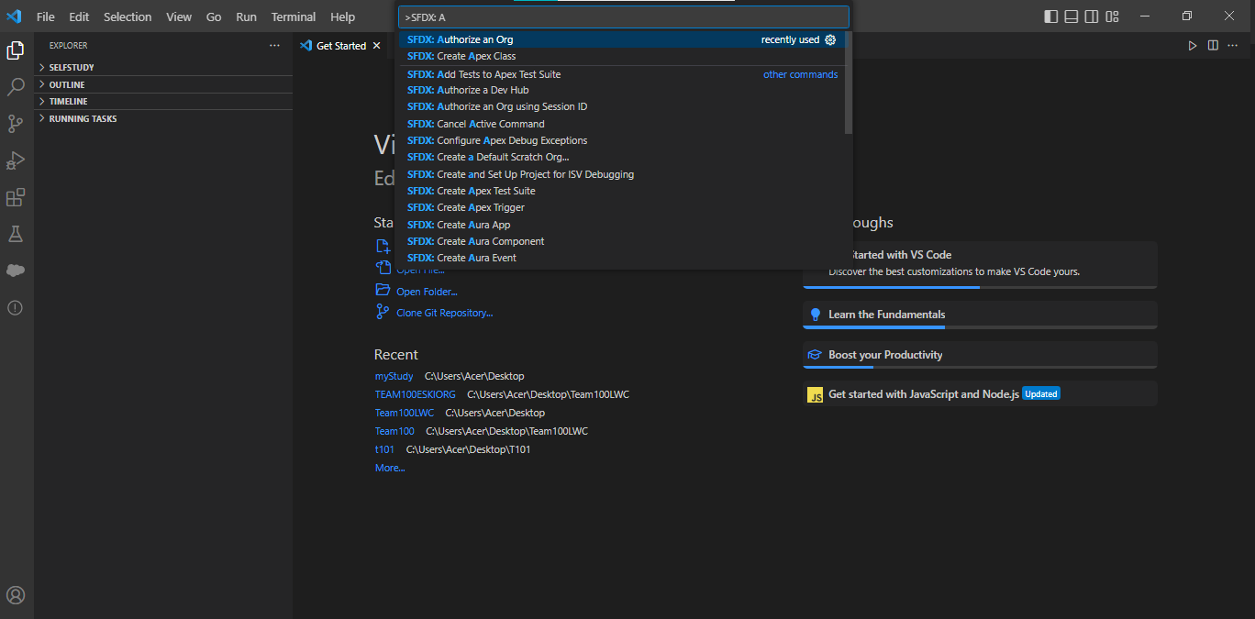

1

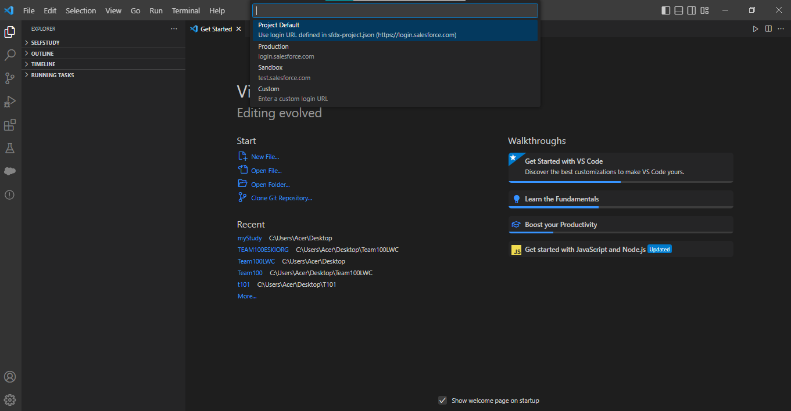

2

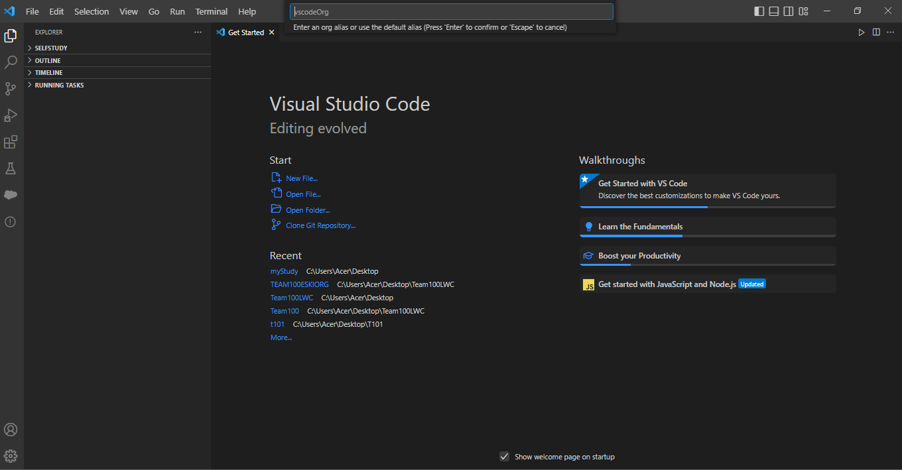

3

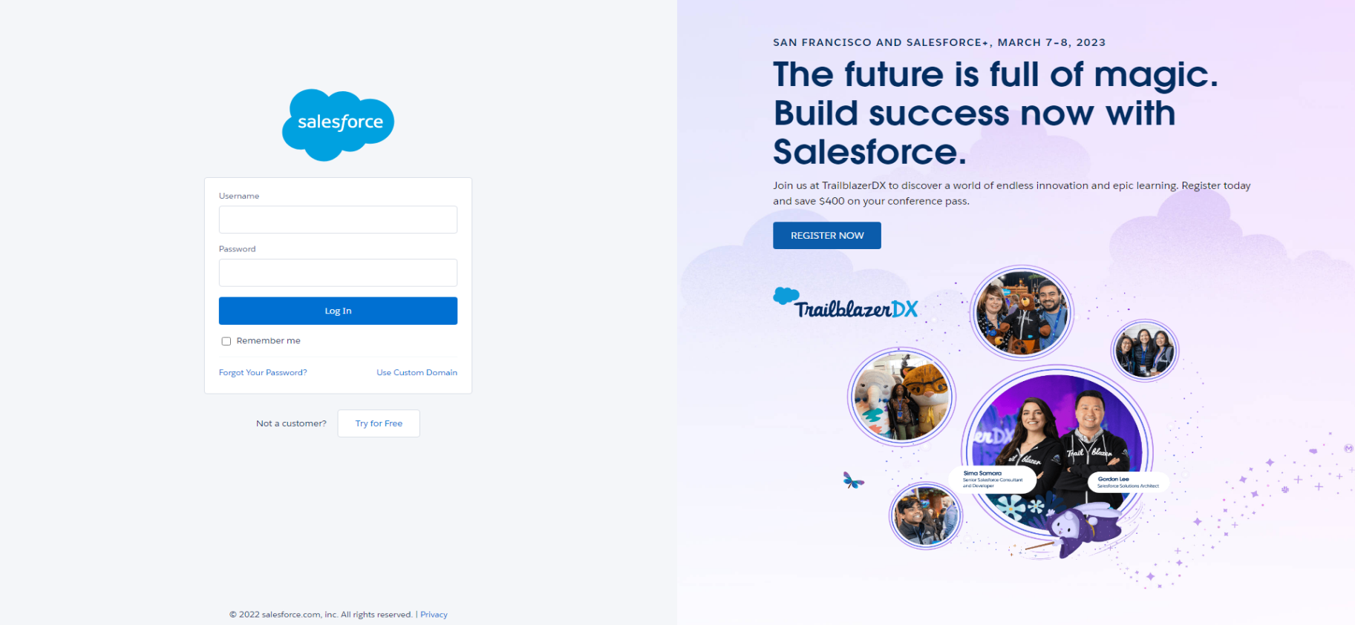 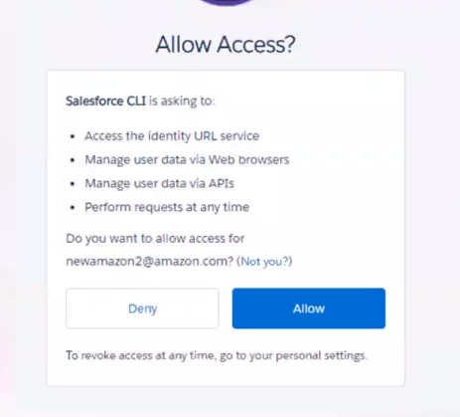

**Note:**

Before connecting to org, project must be created.

You can connect VScode to more than one org.

5

4

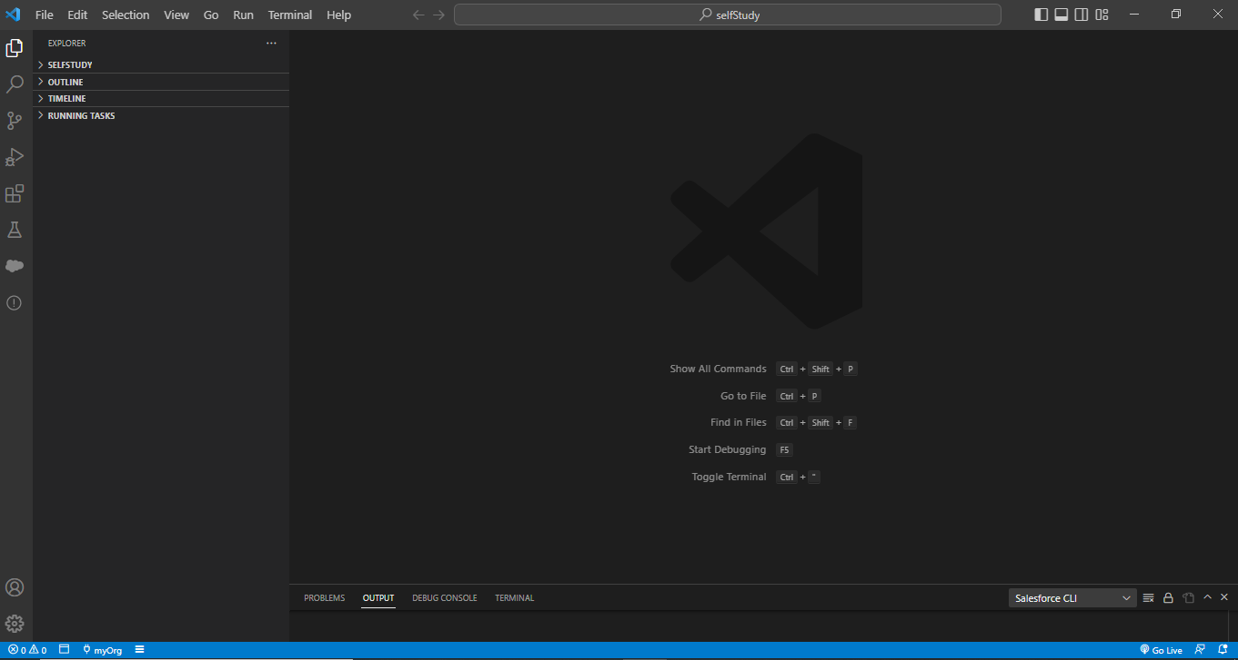

Org name that is given by you.

You can log in to your org by clicking.

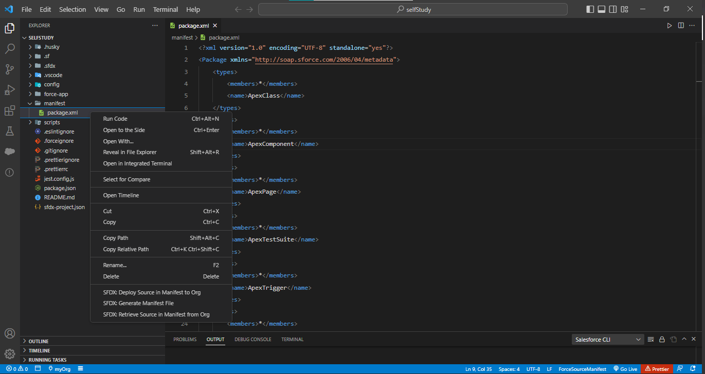

**Note:**

**There are two ways to get all data from org:**

1. **manifest🡪 package.xml (**right click**)**

then select

**SFDX: Retrieve Source in Manifest from Org**

1. Enter **the package.xml file and**

select

**SFDX: Retrieve Source in Manifest from Org**

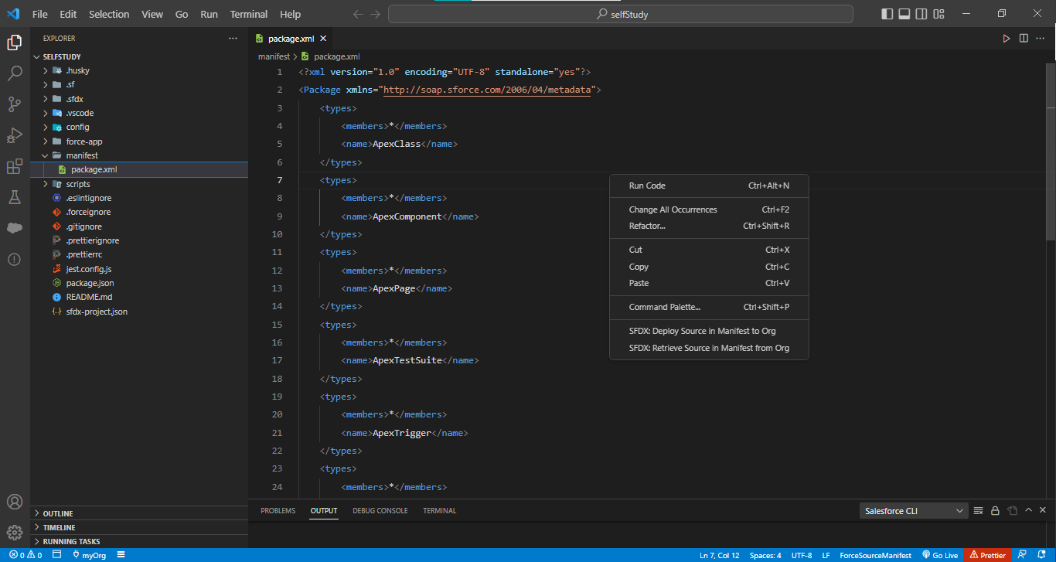

**Deploy: From Vscode to Org**

**Retrieve: From Org to Vscode**

**Deleting any file or folder from VScode doesn’t mean deleting from Org.**

**(be careful not to select from Project and Org.)**